2023
Local Road Asset Management Plan for Chikaming Township
CHIKAMING TOWNSHIP

Project Team
Chikaming Township Road Advisory Committee
Larry Anderson
Paula Dudiak
Tim Brychta
David Bunte, Supervisor, Chikaming Township

Southwest Michigan Planning Commission
K. John Egelhaaf, AICP, Executive Director
Brandon Kovnat, Transportation Planner

Berrien County Road Department
Kevin Stack, Engineering Supervisor
Mike Juengling, Traffic Safety Supervisor

Table of Contents
Introduction 4
Background 5
Summary of the 2018 Plan 5
Township Road Inventory 6
Pavement Conditions 8
Current Pavement Condition 8
Pavement Condition in 2017 8
Treatment Options 9
Budget 10
Estimated Revenue 2024-2028 10
Recommended Maintenance 11
Recommended Miles for Each Treatment Type by Year 11
Project Selection Criteria 13
Recommended Project Summary 13
Forecasted Pavement Condition 14
Managing Unforeseen Circumstances 15
Process for Measuring Plan Success and Making Changes 15
Appendix A: PASER Rating Chart 16
Appendix B: Pavement Condition 2017-2028 17
Appendix C. Descriptions of Treatment Options 18
Appendix D: Recommended Project List 20

Introduction
The Chikaming Local Road Asset Management Plan is a guide for repairing and maintaining the paved local roads within Chikaming Township over the next five years.
Historically, roads with the worst pavement condition were typically fixed first due to an assumption that the bad roads needed attention sooner than roads in better condition. The repairs to fix roads in poor condition are exponentially more costly than maintenance treatments for roads in good or fair condition. Due to limited budgets, maintenance was often skipped. In some cases, poor roads would receive cheaper but less extensive repairs with a shorter service life.
The asset management approach uses data to manage and track road assets in a cost-effective manner. The approach acknowledges that it may be more cost-effective and provide a better overall pavement condition to wait to fix a poor road, so the budget can be better used to prevent far more miles of fair roads from deteriorating further. It may also be beneficial to use a treatment with higher costs if it provides a longer service life and reduces recurring future maintenance needs.
Asset management is defined by MI Public Act 325 of 2018 as “an ongoing process of maintaining, preserving, upgrading, and operating physical assets cost effectively, based on a continuous physical inventory and condition assessment and investment to achieve established performance goals”
These decisions require extensive data on current and past pavement conditions, a list of potential treatments based on the pavement conditions, estimates for how much each treatment will cost, their impact on the lifespan of the pavement on which they are applied, and the total funding available. With this information, a model can be run that calculates the optimal mix of fixes which will result in the overall best pavement condition for a given timeframe.
Asset management ensures that public funds are spent as effectively as possible to maximize the condition of the road network. Decisions are made not just on what seems to make immediate sense but on how decisions will affect road conditions in the longer term. Asset management also provides a transparent decision-making process that allows the public to understand the technical and financial challenges of managing road infrastructure with a limited budget.

Background
In 2017, Chikaming Township's local roads were overwhelmingly poor, with 73% rated as poor, 21% as fair, and 6% rated as good. This was similar to many townships in Berrien County and across the state. The majority of funding for Chikaming Township's roads was provided through the Michigan State Transportation Fund (MTF), with a much smaller amount of funding from federal sources and the township's general funds. These funding sources are very limited, especially when considering the number of miles the Road Department is obligated to maintain. As a result, the County prioritizes its limited funding for maintaining the primary roads while not providing a similar standard for the local roads.
To address this issue, Chikaming Township voters passed a local road millage in 2017. Unlike the funding allocated to the Road Department, the millage funds are levied, controlled, and allocated by Chikaming Township for repairing and maintaining local roads. In order to be the best steward of their residents' tax dollars, the Township partnered with the Southwest Michigan Planning Commission (SWMPC) to produce a Road Asset Management Plan which was approved by the Township board in 2018.
The Plan was intended to help the Township optimize the use of their local road millage dollars, with the primary goal being to achieve an improvement to the Township's average pavement condition year-over-year. The other goal included an emphasis on geographic equity in the distribution of the road fixes applied each year and across the Plan horizon.

Summary of the 2018 Plan
The 2018 Asset Management Plan outlined 10 years of projects from 2018 to 2027. The vast majority of the millage was allocated for reconstructing poor roads, then shifted funds to maintenance to preserve these gains. The Plan had all roads being reconstructed or rehabilitated by 2026. This was predicted to improve the pavement condition to be 86% in good condition and 12% in poor condition by 2023.
The Township shared this Plan with the County Road Department and collaborated on its implementation. No plans can predict the future with precision. Construction methods and costs can change, and global impacts such as the pandemic have unpredictable repercussions. However, while some changes were necessary, the overall philosophy of the Plan was adhered to very well. One of the prominent changes from the 2018 Plan was implementing a less expensive type of treatment that was found to be as effective as the more expensive asphalt reconstruction. This allowed several projects to be moved up a year, but the Plan's overall prioritization of projects was largely followed. Another major difference is that the Plan overestimated the effectiveness of preventive projects, assuming less decay after roads were reconstructed. The 2018 plan predicted the average PASER rating would be 7.7 in 2023, while the actual 2023 average PASER rating is 6.6. This amounts to a roughly 15% variance from the prediction.

Township Road Inventory

Michigan Public Act 51 of 1951 (PA 51) defines how funds from the Michigan Transportation Fund (MTF) are distributed to state and local road owners and how these funds may be spent. To achieve this, PA 51 classifies roads by ownership and funding category. Roads within Chikaming Township are classified as either Trunkline (MDOT maintained), County Primary, County Local, or Non-Certified (non-public roads such as privately maintained subdivisions). The only road within Chikaming Township that is maintained by MDOT is I-94. Within the Township, the Berrien County Road Department maintains the remaining 68.5 miles of public roads.
Out of these 68.5 miles, 21.4 miles are classified as County Primary. These are higher-traffic roads typically used far more for travel through the Township than by residents or visitors accessing individual properties. Due to the higher traffic volumes, the Road Department devotes far more of its budget toward maintaining primary roads than local roads.
The Township contains 47.1 miles of County Local roads which are used mostly by Chikaming residents and visitors to access homes or other properties. Approximately 8 miles of the local roads are unpaved (gravel) and were excluded from the Plan. Concrete roads account for less than 0.1% of the local road miles and consist of the bridge decks over I-94. These bridge decks are maintained by MDOT as part of the interstate maintenance.
Sealcoat pavement: Sealcoat pavement is a gravel road that has been sealed with a thin asphalt binder coating that has stone chips spread on top (not to be confused with a chip seal treatment over HMA pavement). The gravel layer provides structure to support traffic, while the asphalt binder coating and stone chips protect the surface from water and eliminate the need for grading the gravel underneath.

Asphalt Pavement Hot-Mix Asphalt (HMA) Pavement: or simply asphalt is a roadway with a stone and sand base to support traffic and a surface layer of asphalt that provides additional support and protection from weather damage. A typical newly reconstructed asphalt pavement has a service life of 18 years before major rehabilitation is necessary.

To add confusion both surface types can sometimes have an asphalt layer, or a sealcoat layer added on top. This means that the defining feature in the base layer, and occasionally pavement type, is miss-classified based only on surface appearance.
This Asset Management Plan will cover Chikaming Township’s 39 miles of paved local roads, which are split between 17.3 miles of asphalt pavement and 21.7 miles of sealcoat pavement.

Surface Type | Miles | Percentage
Asphalt | 17.3 | 36.8%
Sealcoat | 21.7 | 46.0%
Gravel | 8.0 | 17.1%
Concrete | 0.04 | 0.1%
Total | 47.1 | 100%

A map showing the locations of Chikaming Township’s paved local roads can be found on the following page.

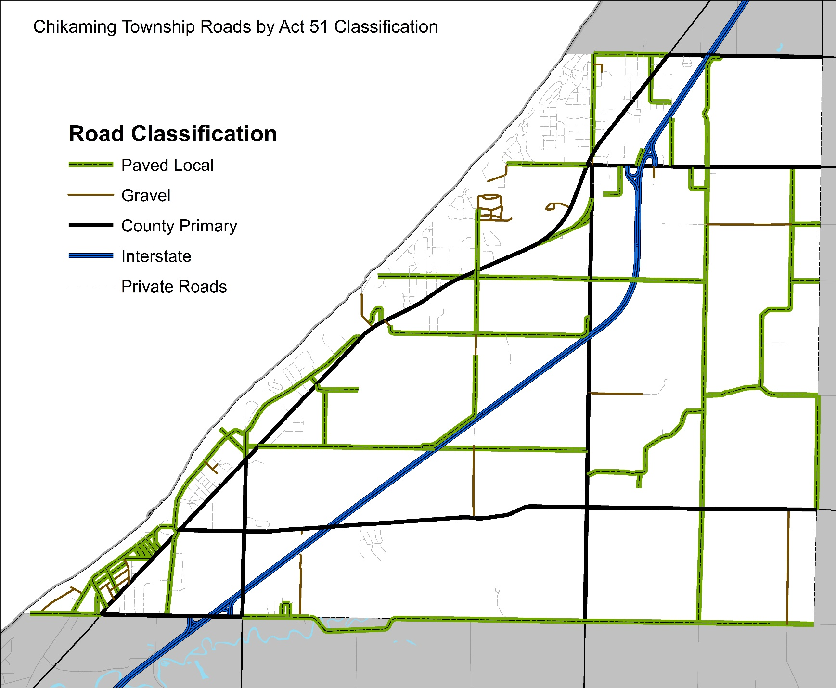
.

Pavement Conditions

The standard method for evaluating pavement condition in Michigan, adopted by the Michigan Transportation Asset Management Council (TAMC), is the Pavement Surface Evaluation Rating (PASER) technique. PASER employs a visual survey method to assess road condition on a scale of 1 to 10, with 1 indicating failed pavement and 10 representing perfect condition. PASER utilizes visible defects on a road to estimate its overall condition and determine the remaining service life. For simplified reporting, TAMC groups ratings into Good (8-10), Fair (5-7), and Poor (1-4). Detailed information regarding the defects associated with each PASER value can be found in Appendix A.
Prior to 2017, there were limited and incomplete ratings for Chikaming's local roads. SWMPC assessed pavement conditions (using PASER) for local roads in 2017 as part of the development of the 2018 Asset Management Plan. Subsequently, the Berrien County Road Department rated local roads in 2019, 2021, and 2023, with plans to continue biennial ratings. Condition assessments were also conducted by SWMPC in 2023.

Current Pavement Condition
In 2023, Chikaming's local roads were rated as 36% in good condition, 51% in fair condition, and 13% in poor condition. A more detailed breakdown reveals that most fair roads are at the upper end of the fair category, with approximately 38% of all local road miles rated as PASER 7. The average PASER rating for Township local roads is 6.6.

Pavement Condition in 2017
Back in 2017, local roads were rated as 6% good, 20% Fair, and 73% poor. Notably, a large portion of roads were failing with roughly 1/3 (33.4%) rated a PASER of 1 or 2. This condition has since risen steadily, as the majority of the poor roads have been repaired over the last six years.
Average PASER
2017 | 2023
3.87 | 6.6

More details on the pavement condition ratings can be found in the Appendix B.

Treatment Options

There are a vast number of road treatments in common use. The Berrien County Road Department has settled on several treatments for local roads, which they have found to be cost-effective based on the County's local conditions. Details on the exact work for any project are determined by a project engineer before construction. Using the average costs per mile for the general treatment type can provide a reliable estimate for planning. Each treatment has pavement conditions for which it is considered effective. This is accounted for in models by assigning a range of PASER values when the treatment can be chosen. These values are called the “PASER "trigger." Treatments are also assigned a revised PASER rating that can be expected upon the completion of construction. This is known as the PASER "reset,” Only a complete reconstruction will bring a road to a PASER of 10. For reporting purposes, treatments are grouped into general categories based on how extensive the fix is. The treatments available for Chikaming Township’s local roads are shown below. The estimated costs for each treatment are based on the contractor bids that the Berrien County Road Department received in 2023, with an increase of 5% to account for inflation.

Potential Treatment Types for Chikaming’s Local Roads
Category | Treatment | Applicable PASER | Reset | Cost/Mile  2024 Estimate
Light PM | Crackseal | 7-7 | 7 | $4,066
Heavy PM | Sealcoat | 5-6 | 8 | $33,338
Rehabilitation | HMA Scratch & Sealcoat | 3-4 | 8 | $97,709
Rehabilitation | 2in. HMA Overlay | 3-4 | 9 | $215,340
Reconstruction -Sealcoat | Grind, Gravel, Prime Double Seal | 1-2 | 10 | $105,585
Reconstruction – Asphalt | Asphalt Reconstruction | 1-2 | 10 | $408,049
The costs are presented are for a two-lane road.

More detailed descriptions of the treatment options can be found in Appendix C.

Budget

The funding available to carry out this Plan’s recommendations comes from the Township’s local road millage. In 2017 the Township approved the millage for 7 years. The millage was approved again in 2023. The millage was approved at 1 mill (0.001% of assessed property value).

In 2017, the Township had a local road budget of approximately $615,000. This amount has grown each year with an approximate budget of $700,000 in 2023.

Estimated Revenue 2024-2028

The Township projects a revenue of approximately $700,000 for 2024. Because property values are highly variable, the Plan will not include a prediction for any growth in the millage revenue. For planning purposes, the estimated budget is being held constant for all 5 Plan years. To account for unforeseen expenses, 10% of the budget will be held in reserve as the Township’s standard practice. For calculating the optimal mix of fixes, a maximum annual expense of $630,000 has been used in this Plan.

The projects and budget for 2024 were developed at the same time as this Plan. In 2024 the Township anticipates the use of remaining funds from previous years on projects during that year in order to coordinate with development projects anticipated in 2024. The amount to be utilized in 2024 will be $1,150,000.

Recommended Maintenance

The Roadsoft Pavement Optimization tool was utilized as a computer model to calculate the recommended 2025-2028 maintenance strategy. Roadsoft calculates the anticipated rate of deterioration for each road segment based on past ratings and established patterns of deterioration for each pavement type. The forecasted PASER rating is used to determine how many miles are eligible for each treatment type based on the treatment PASER trigger. Roadsoft then calculates the number of lane miles of each treatment, known as a "mix-of-fixes," that will yield the highest or "optimal" PASER increases while remaining within the Township's available yearly budget.

Pavement Condition History
Treatment Costs
Available Budget
Treatment PASER Trigger & Reset
Optimized Mix of Fixes Per Year

Recommended Miles for Each Treatment Type by Year
In 2023, there are 5.1 miles of paved local roads in poor condition. The projects selected for 2024 will bring 3.7 of these miles to good condition. In 2025 the vast majority of the remaining 1.4 miles in poor condition will be repaired. From 2026, going forward, a maintenance plan of routine crack sealing and regular sealcoating is recommended. The two tables below show the number of miles recommended for each treatment category and the overall budget based on the estimated treatment cost per mile.

Recommended Miles for Each Treatment Type per Year
Treatment Type | Fixes Included | 2024 | 2025 | 2026 | 2027 | 2028
Reconstruction | Asphalt Reconstruction &  Sealcoat Grind Gravel, Prime & Double Seal | 1.6 | 0.6 | 0.04 | 0.0 | 0.0
Rehabilitation | Asphalt Overlay | 2.1 | 0.9 | 0.02 | 0.0 | 0.0
Heavy PM | Sealcoat | 0.0 | 6.0 | 7.7 | 7.5 | 11.3
Light PM | Chipseal | 0.0 | 0.0 | 10.2 | 9.1 | 8.3

Estimated Costs Per Year
 | 2024 | 2025 | 2026 | 2027 | 2028
Reconstruction | $750,000 | $241,158 | $4,212 | $0 | $0
Rehabilitation | $400,000 | $189,500 | $2,155 | $0 | $0
Heavy PM | $0 | $199,342 | $268,119 | $275,681 | $435,539
Light PM | $0 | $0 | $43,639 | $40,686 | $39,221
Total | $1,150,000 | $630,000 | $318,125 | $316,367 | $474,760

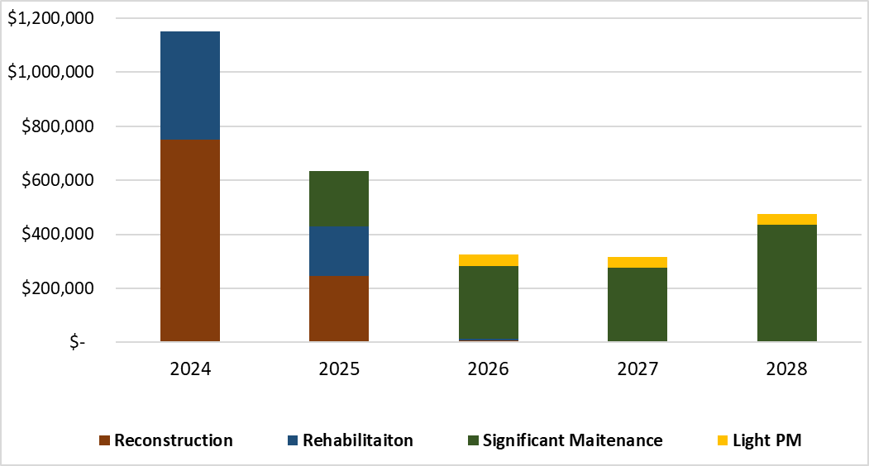
The number of miles dedicated for project work for 2024 and 2025 is significantly lower than in the following years. The roads involved require the most expensive fixes, thus there are fewer miles receiving treatments. The most substantial expenses are incurred in 2024, followed by the next highest costs in 2025. This discrepancy arises from the reconstruction and rehabilitation projects scheduled for 2024 and 2025, which come with a significantly higher cost per mile compared to the maintenance projects recommended for 2026-2028.

Project Selection Criteria
While Roadsoft provides an optimal number of miles of each fix per year, it cannot determine which specific roads to apply these fixes to. In the 2018 Plan, there were far more miles in need of repairs than could be completed in any given year. To address this, the 2018 Plan included criteria for prioritizing projects, with geographic equity as an additional criterion. In 2023, with most roads in good or fair condition, the Township has the budget to treat every road in need of maintenance. Therefore, prioritization becomes much less important. The primary factor is based on condition which in turn is based on when the road was last repaired.
Major Reconstruction/Rehabilitation Projects

2024
- Roads north of Union Pier Rd. between Lakeside Rd. and Red Arrow Hwy
- Harbert from Three Oaks to Flynn
- Pier Road, East Rd. & Lakeside Rd
2025
- Algonquin Trail
- Canterbury, Butterfield Rd, & Mayfair Ave
- Garden Acres
- Tower Hill from Red Arrow to Browntown Rd.
2026
- Locke Rd & Red Arrow Intersection
- Three Oaks directly south of Red Arrow

Recommended Project Summary
In 2023, approximately 5.1 miles of Chikaming’s local roads are in poor condition. The projects chosen in 2024 include 3.7 miles of reconstruction or rehabilitation. In 2025 another 1.4 miles of poor roads will be repaired. This will leave only 0.06 miles of poor roads remaining, which are recommended to be repaired in 2026.
The detailed locations for all projects are shown in the Appendix D. Note that the Crack Sealing locations are not specifically shown. While the exact locations are not easy to predict, the budget available for Crack Sealing is clearly indicated.

Forecasted Pavement Condition

Most of the improvement in Pavement Condition is forecasted to occur in 2024, primarily due to the Reconstruction projects. Another significant improvement is expected in 2025, as the last remaining roads in poor condition are repaired (with minimal repairs to poor roads in 2026). Beyond 2025, ongoing preventive maintenance is projected to keep pavement condition consistently good, with only minor fluctuations each year.
From 2023 to 2028, Chikaming's local roads are forecasted to improve from approximately 36% in good condition, 50% in fair condition, and 13% in poor condition in 2023 to approximately 45% in good condition and 55% in fair condition by 2028.
By 2026, the model predicts that each spring, around 7-12 miles or 20-30% of the roads will reach a PASER of 6. The recommendation is to apply a sealcoat treatment to these roads, elevating them to a PASER rating of 8. This approach means that by the end of the construction season, all roads are forecasted to have a PASER of 7 or 8. Consequently, the roads will be considered as approximately half in good condition and half in fair condition. The average PASER rating is expected to be around 7.5, as all the fair roads will be at the upper end of the fair classification. Furthermore, there will be a minimal disparity in condition between the higher and lower-rated roads.

Managing Unforeseen Circumstances
This Plan is based on the best estimates for future conditions available, but variations in future conditions are to be expected. Most of these changes should have minimal impact. The conditions that may require deviations from the recommended project list include:
- Extreme weather events or other hazards that cause major road damage.
- Unforeseen road condition issues which necessitate more costly repairs (e.g. drainage or erosion failures, frost heaves).
- Significant changes in construction costs either from higher inflation or cost reductions.
- Lower than expected millage revenue.

This Plan does not require the Township to utilize its full yearly budget after FY 2025. Therefore, if construction costs decrease or the millage revenue increases, the Plan does not need to be altered. Since the Township would not be using the full funding it would have available, additional funds will impact the planned preventive maintenance. Having a healthy reserve budget is useful though, because it will allow the Township to address unforeseen events. With its estimated budget, the Township should be able to address occasional large repairs as needed, without making any sacrifices for preventive maintenance.

Process for Measuring Plan Success and Making Changes

Because variations in future conditions are to be expected, a process for determining which conditions are significant enough to warrant changes to the Plan is required. Each fall, the Road Department (or SWMPC) should run the Roadsoft model using the latest PASER data, construction cost estimates, and estimated budget. This will help determine if any conditions are significant enough to make an alternate treatment plan more cost-effective.

The Berrien County Road Department has been collecting PASER ratings for the Township’s local roads every other year starting in 2019, and it is recommended this be continued. Regular ratings will allow the Township to compare the actual pavement condition to what was predicted. If the observed PASER rating for any given road is significantly different from what this Plan has forecasted, it is likely that some of the assumptions made in the Plan differ significantly from what has actually been experienced. If so, changes to the Plan going forward may be required. A review of the Plan is recommended if the observed average PASER is 15% lower than forecasted. This review should be conducted between the Township and the Road Department to examine what factors might be causing the differences, and what changes may be required.

Appendix A: PASER Rating Chart

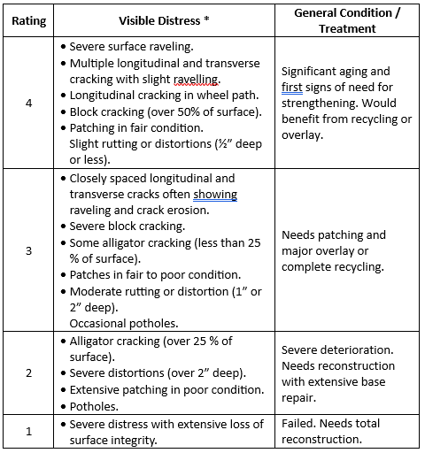
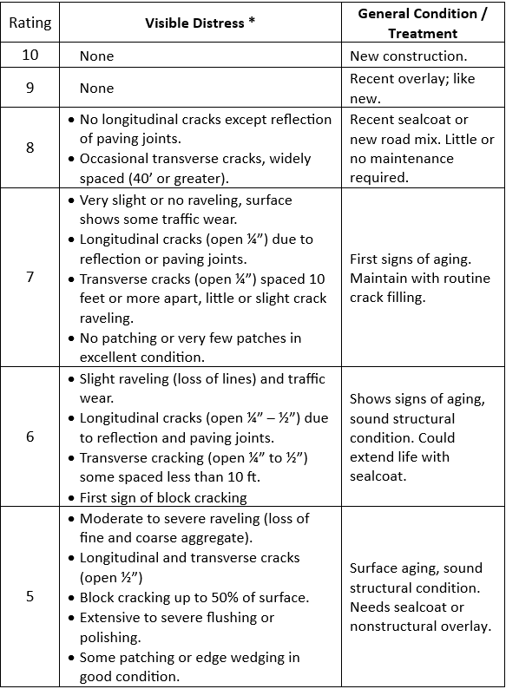

Appendix B: Pavement Condition 2017-2028

Percent of Chikaming Local Roads by PASER Value 2017-2028

 | 1 | 2 | 3 | 4 | 5 | 6 | 7 | 8 | 9 | 10 | Average
2017 | 1.2% | 32.2% | 8.5% | 31.0% | 6.6% | 11.0% | 3.2% | 6.3% | 0.0% | 0.0% | 3.87
2019 | 1.2% | 25.4% | 10.8% | 8.1% | 0.0% | 0.0% | 14.3% | 25.6% | 4.9% | 9.8% | 5.64
2021 | 2.9% | 7.8% | 5.0% | 7.2% | 0.1% | 20.1% | 25.4% | 16.4% | 10.8% | 4.2% | 6.32
2023 | 2.0% | 7.8% | 2.9% | 0.4% | 4.2% | 8.9% | 37.9% | 25.0% | 11.0% | 0.0% | 6.6
2024 | 0.3% | 1.3% | 2.3% | 0.0% | 4.2% | 8.4% | 37.9% | 25.0% | 18.9% | 1.8% | 7.34
2025 | 0.1% | 0.0% | 0.0% | 0.1% | 0.0% | 0.2% | 53.6% | 31.4% | 13.2% | 1.5% | 7.61
2026 | 0.0% | 0.0% | 0.0% | 0.0% | 0.0% | 0.0% | 62.4% | 35.9% | 1.6% | 0.1% | 7.39
2027 | 0.0% | 0.0% | 0.0% | 0.0% | 0.0% | 0.0% | 66.5% | 33.4% | 0.1% | 0.0% | 7.33
2028 | 0.0% | 0.0% | 0.0% | 0.0% | 0.0% | 0.0% | 54.1% | 45.9% | 0.0% | 0.0% | 7.46

Appendix C. Descriptions of Treatment Options

Light Preventive Maintenance Treatments
Crack Seal: Also known as Crack-Fill, is a treatment that applies a thin asphalt sealant to cracks in the roadway. Filling cracks helps prevent water infiltration which softens the pavement structure. Untreated cracks allow traffic loads to cause more damage to the pavement than in normal dry conditions. Ideally, pavement cracks are sealed early in the life of the pavement to keep the base strong and the pavement functioning as long as possible. Crack filling effectiveness lasts approximately two years. Though it does not last long compared to other treatments, it has a very-low cost compared to other treatments. This makes it cost effective when options are considered during the life of road.

Heavy Preventive Maintenance Treatments
Sealcoat: Also known as a Chip Seal, is a two-part treatment that starts with liquid asphalt sprayed onto the old pavement surface followed by a single layer of small stone chips spread onto the wet liquid asphalt layer. The liquid asphalt seals the pavement from water and debris and holds the stone chips in place, providing a new wearing surface for traffic that can correct friction problems and helps to prevent further surface deterioration. Sealcoats do not improve structural support and are best applied to pavements that are not exhibiting problems supporting traffic weight. These treatments can last approximately five years but more frequent sealcoating can extend the service life of a road even further.

Rehabilitation Treatments
Hot-Mix Asphalt (HMA) Overlay: Also known as an Asphalt Overlay, is the application of a layer of new asphalt placed on top of the existing pavement. Depending on the overlay thickness, this treatment can add significant structural strength. This treatment also creates a new wearing surface for traffic and seals the pavement from water, debris, and sunlight damage. An HMA overlay has a five-to-ten-year service life.
HMA Scratch and Sealcoat: Also referred to as a Scratch and Seal, is a combination of two treatment types. The first treatment, the scratch course, is a thin layer of asphalt used to make the road level and smooth. On top of the scratch course, the second treatment, a sealcoat, is applied. A Scratch and Seal is used when structural support is required. HMA Scratch and Sealcoat differs from a standard HMA Overlay in that, in an HMA Overlay, the asphalt provides support and protection for the surface. In a Scratch and Seal, asphalt is used for structural support, while the additional sealcoat layer is used to provide protection for the surface.

Reconstruction Treatments
Grind, Gravel, Prime and Double Seal (G,G,P,DS): Is the name for the reconstruction of a sealcoat pavement. This is a multi-step treatment. First, the top layers of stones are ground away to reveal the gravel underneath. Next, the gravel is repaired and smoothed as needed. Finally, an asphalt emulsion (the prime) is added before two layers of sealcoat treatments. This treatment is the only way for a sealcoat pavement to achieve a PASER rating of 10.
Asphalt Reconstruction: Often simply referred to as a reconstruction. This treatment is required for failing or failed pavements. The old pavement and base is completely removed before constructing an entirely new road. Every pavement eventually requires reconstruction and it is usually done as a last resort after more cost-effective treatments have been done, or if the road requires significant changes to road geometry, base, or buried utilities. Compared to the other treatments, which are all improvements of the existing road, reconstruction is the most extensive rehabilitation of the roadway and therefore, also the most expensive per mile and most disruptive to regular traffic patterns. With regular preventive maintenance, a newly reconstructed road should last approximately 20 years before reconstruction is required again.

Appendix D: Recommended Project List

Selected Projects for 2024
Road | From | To | Treatment | Estimated cost
Berrien St. | Red Arrow | Lakeshore Dr. | HMA + Drain Repairs | $61,268
Center Ave. | Red Arrow | Lakeshore Dr. | HMA + Drain Repairs | $43,214
Goodwin Ave. | Red Arrow | Lakeshore Dr. | HMA + Drain Repairs | $48,400
Nolan Ave. | Goodwin | Oakwood | HMA + Drain Repairs | $62,036
Greenwood Ave. | Townline | Goodwin | HMA + Drain Repairs | $29,578
Howard St. | Berrien St. | Lakeshore | HMA + Drain Repairs | $23,239
Isobel St. | Berrien St. | Lakeshore | HMA + Drain Repairs | $29,578
Nannene Ave. | Red Arrow | Lakeshore Dr. | HMA + Drain Repairs | $32,650
Victor Ave. | Red Arrow | Lakeshore Dr. | HMA + Drain Repairs | $34,571
Streed Ave. | Red Arrow | Lakeshore Dr. | HMA + Drain Repairs | $27,657
Harbert Rd. | Three Oaks Rd. | Flynn | Trench & HMA Overlay | $350,000
East Rd. | Red Arrow | Lakeside | Reconstruction | $50,000
Lakeside Rd. | Red Arrow | Lakeshore Dr. | Reconstruction | $250,000
Pier Rd. | Lakeside | End | Reconstruction | $100,000
Berrien St. | Red Arrow | Lakeshore Dr. | HMA + Drain Repairs | $61,268
Center Ave. | Red Arrow | Lakeshore Dr. | HMA + Drain Repairs | $43,214
Goodwin Ave. | Red Arrow | Lakeshore Dr. | HMA + Drain Repairs | $48,400

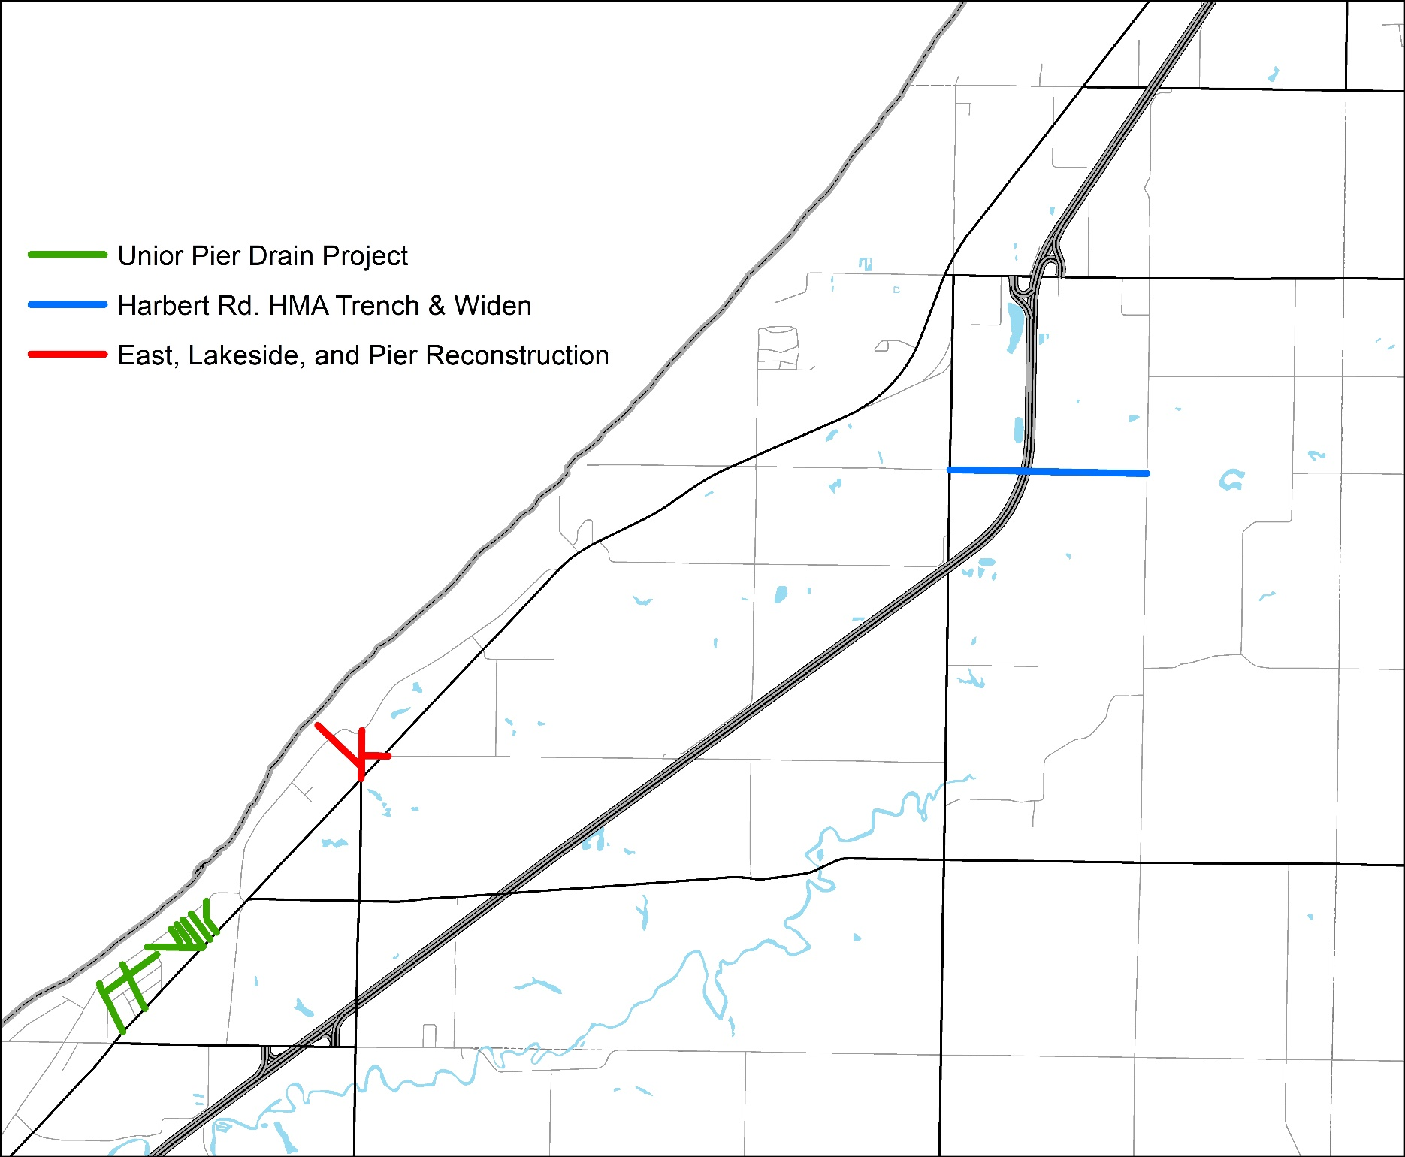
2024 Selected Projects

Recommended Projects for 2025
Road | From | To | Treatment | Estimated cost
Tower Hill Rd | Red Arrow | Browntown | HMA Overlay | $189,495
Algonquin Trl | Indian Trail | Dead End or Start | Reconstruction | $55,904
Butterfield Rd | Elm Valley | Mayfair | Reconstruction | $47,335
Canterbury | Elm Valley | Mayfair | Reconstruction | $47,743
Garden Acres | Sawyer | End/to Private Drive | Reconstruction | $65,697
Mayfair Ave | Canterbury | Butterfield | Reconstruction | $24,483
Arlington Dr | Sawyer | Dead End or Start | Sealcoat | $13,102
E Wolcott Ave | Wolcott | Sandpiper | Sealcoat | $6,168
Harbert Rd | Dead End or Start | Red Arrow | Sealcoat | $24,970
N Wolcott St | Wolcott | Browntown | Sealcoat | $13,535
Peck Ave | Flynn | Sawyer | Sealcoat | $10,801
S Wolcott St | Sawyer | Dead End or Start | Sealcoat | $14,169
Townline Ave | Williams | Red Arrow | Sealcoat | $6,101
Townline Ave | Lakeside | Schwark | Sealcoat | $69,876
W East Rd | Bridge 804 | Three Oaks | Sealcoat | $43,739

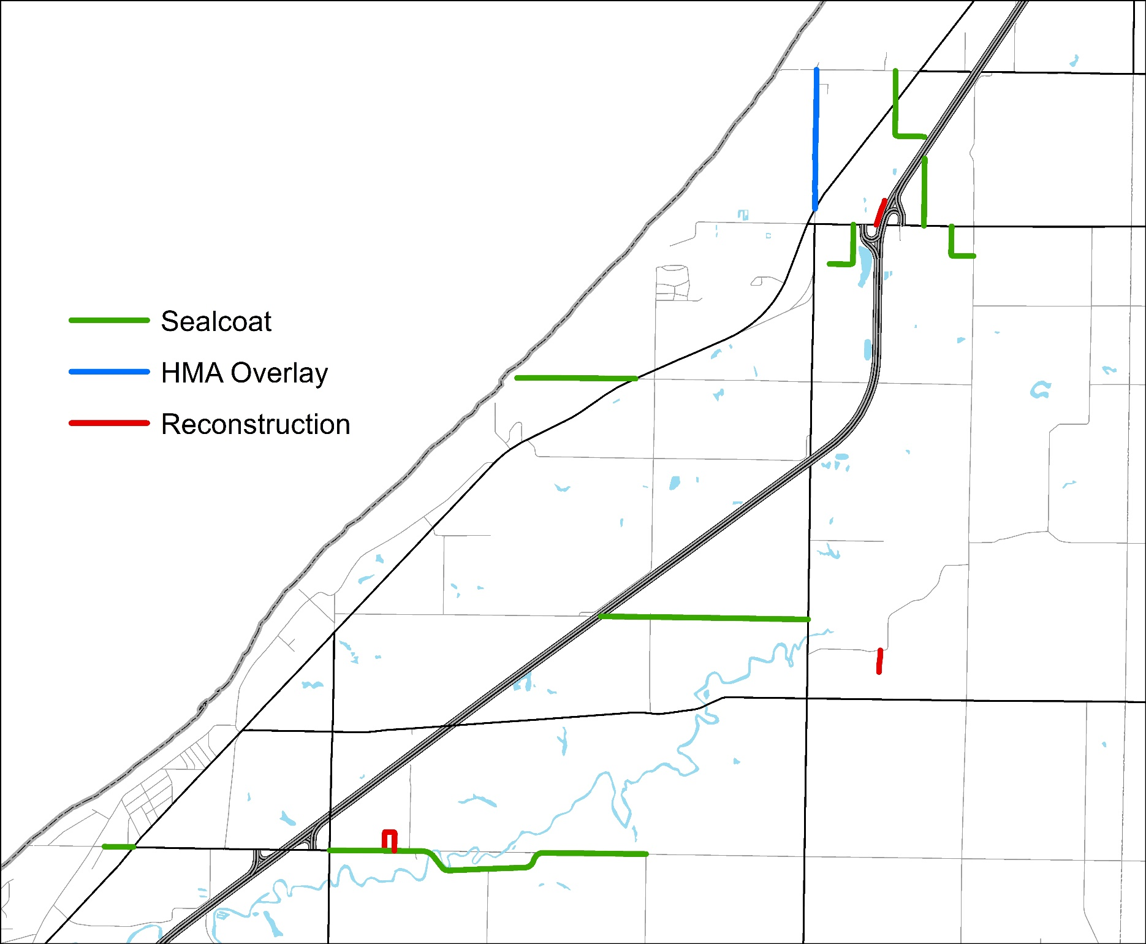
2025 Recommended Projects
Recommended Projects for 2026
Road | From | To | Treatment | Estimated cost
Locke Rd | Red Arrow | 0.04 mi | Grind, Gravel, Prime & Double Seal | $4,634
Harbert Rd | Red Arrow | Shamrock | Sealcoat | $7,526
Indian Trail Rd | Three Oaks | Flynn | Sealcoat | $48,167
S Brown Rd | East | Wilson | Sealcoat | $17,397
S Prairie Rd | East | End | Sealcoat | $37,910
S Prairie Rd | Harbert | Home | Sealcoat | $21,038
Townline Ave | Three Oaks | City/Twp Line | Sealcoat | $70,185
W East Rd | Red Arrow | Bridge 804 | Sealcoat | $53,172
W Wilson Rd | Red Arrow | Dead End or Start | Sealcoat | $13,967

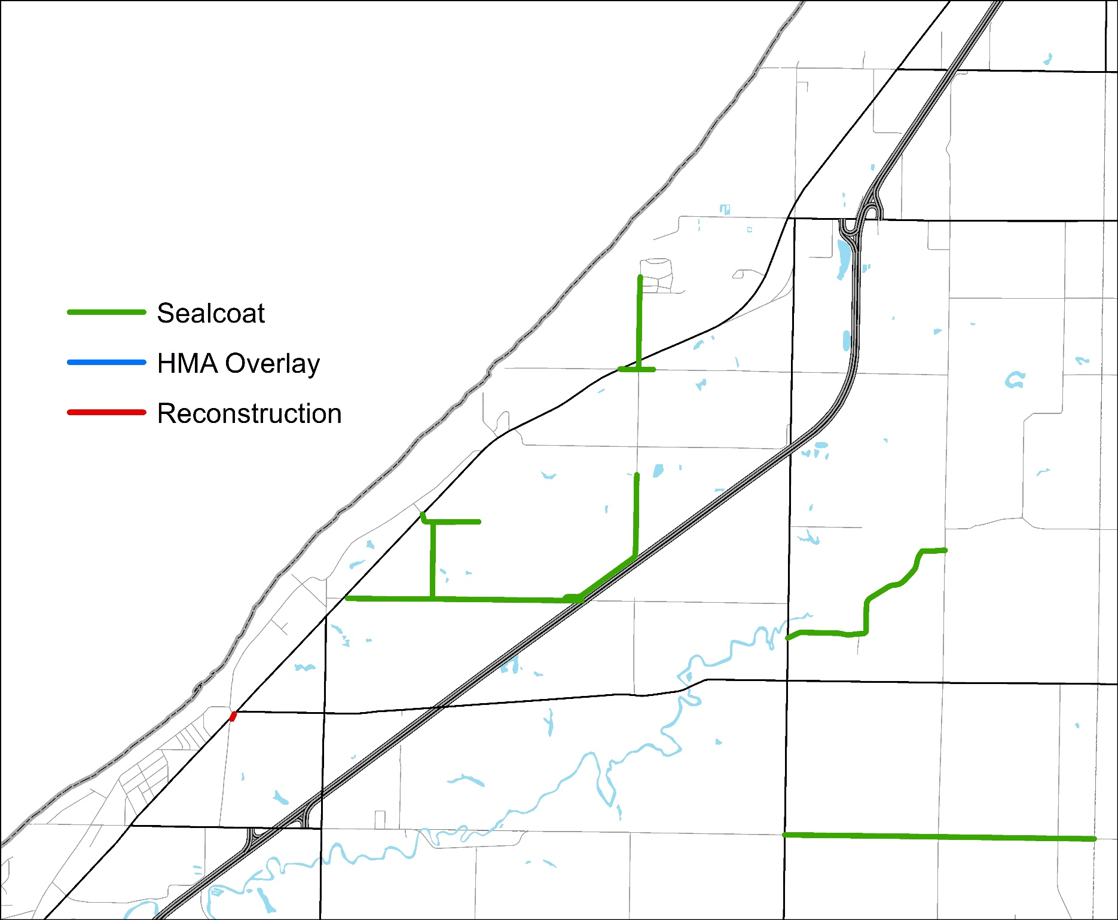
2026 Recommended Projects
Recommended Projects for 2027
Road | From | To | Treatment | Estimated cost
Flynn Rd | Elm Valley | Harbert | Sealcoat | $110,081
Lakeshore Rd | Union Pier | Lakeshore | Sealcoat | $44,106
Locke Rd | Union Pier | Lakeshore | Sealcoat | $28,081
S Prairie Rd | Youngren | Harbert | Sealcoat | $18,378
W Youngren Rd | CSX Transportation | Three Oaks | Sealcoat | $70,753

2027 Recommended Projects
2027 Recommended Projects
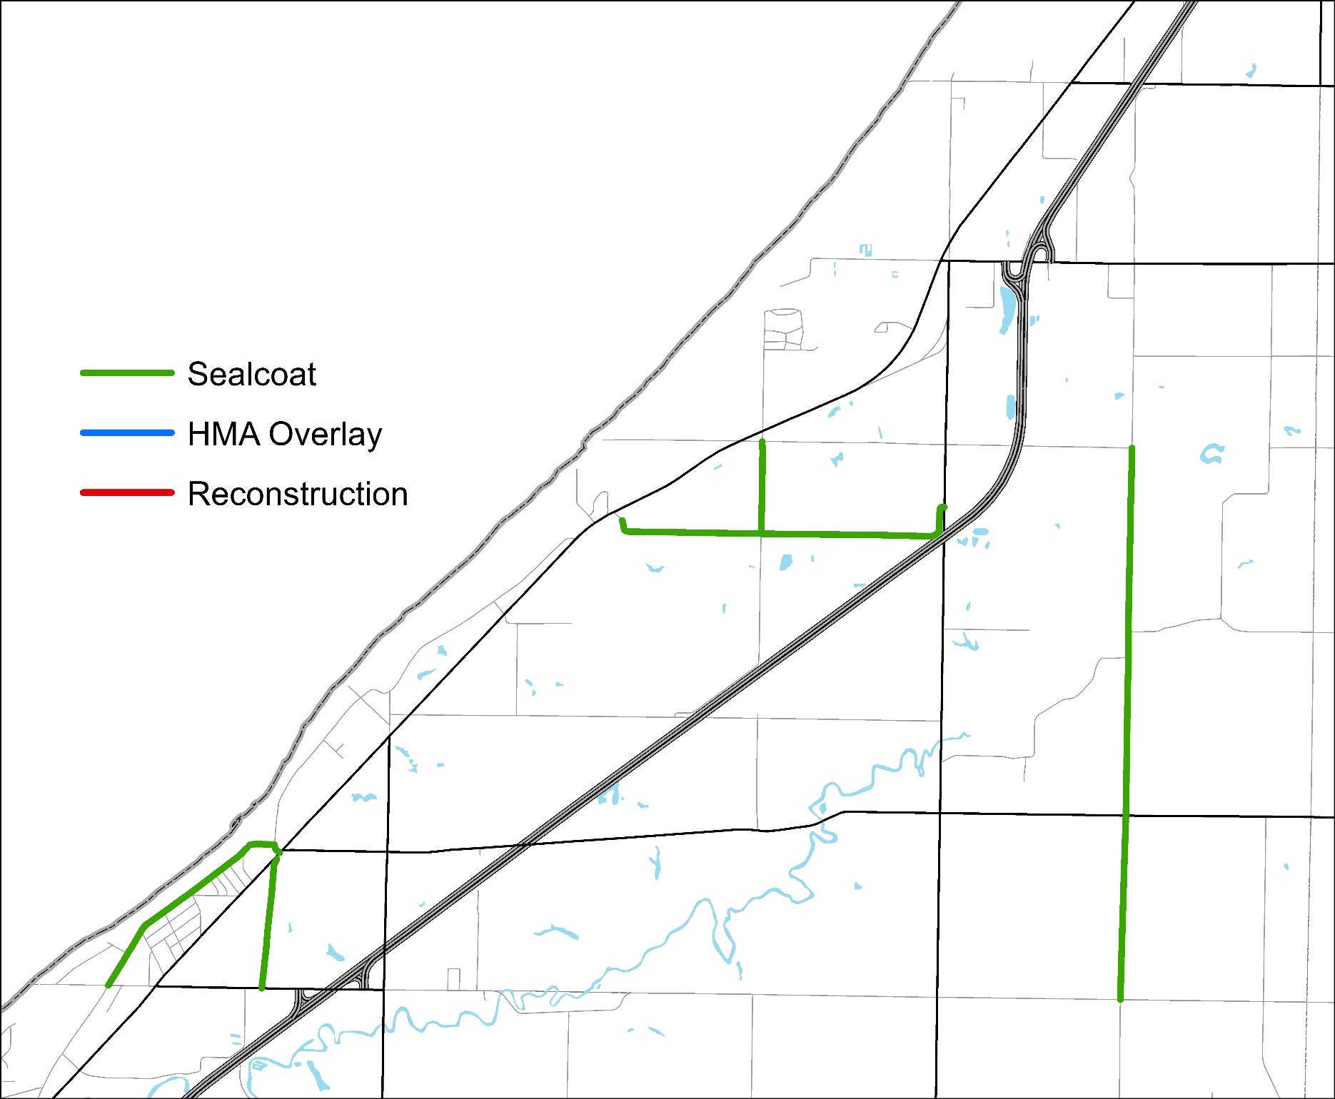
Recommended Projects for 2028
Road | From | To | Treatment | Estimated cost
E Wolcott Ave | Wolcott | Sandpiper | Sealcoat | $7,140
Flynn Rd | Harbert | Browntown | Sealcoat | $77,803
Hanover Rd | Minnich | City/Twp Line | Sealcoat | $9,687
Harbert Rd | Dead End or Start | Red Arrow | Sealcoat | $28,906
Harbert Rd | Three Oaks | Flynn | Sealcoat | $38,400
Minnich Rd | Kaiser | Sawyer | Sealcoat | $82,357
N Wolcott St | Wolcott | Browntown | Sealcoat | $15,669
S Brown Rd | East | Wilson | Sealcoat | $19,181
S Prairie Rd | East | End | Sealcoat | $41,796
Townline Ave | Warren Woods State Park | Three Oaks | Sealcoat | $26,359

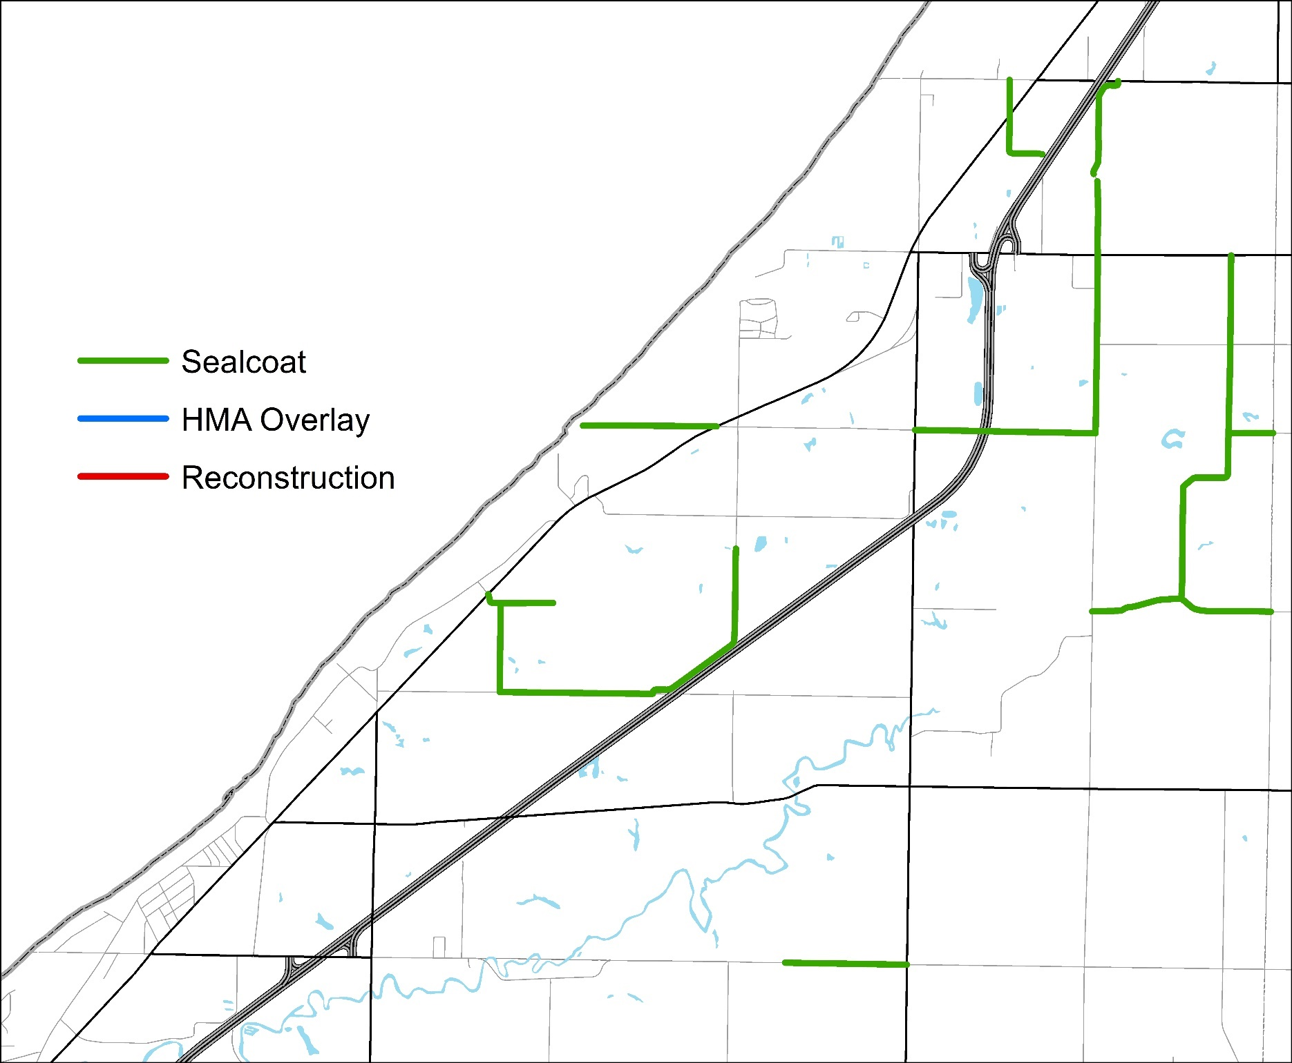
2028 Recommended Projects

